**Azure DevOps** supports a collaborative culture and set of processes that bring together developers, project managers, and contributors to develop software. It allows organizations to create and improve products at a faster pace than they can with traditional software development approaches.

|  |  |
| --- | --- |
| [Azure Boards](https://azure.microsoft.com/services/devops/boards/) | Delivers a suite of Agile tools to support planning and tracking work, code defects, and issues using Kanban and Scrum methods. |
| [Azure Repos](https://azure.microsoft.com/services/devops/repos/) | Provides Git repositories or Team Foundation Version Control (TFVC) for source control of your code. |
| [Azure Pipelines](https://azure.microsoft.com/services/devops/pipelines/) | Provides build and release services to support continuous integration and delivery of your applications |
| [Azure Test Plans](https://azure.microsoft.com/products/devops/test-plans/) | Provides several tools to test your applications, including manual/exploratory testing and continuous testing. |
| [Azure Artifacts](https://azure.microsoft.com/products/devops/artifacts/) | Allows teams to share packages such as Maven, npm, NuGet, and more from public and private sources and integrate package sharing into your pipelines. |

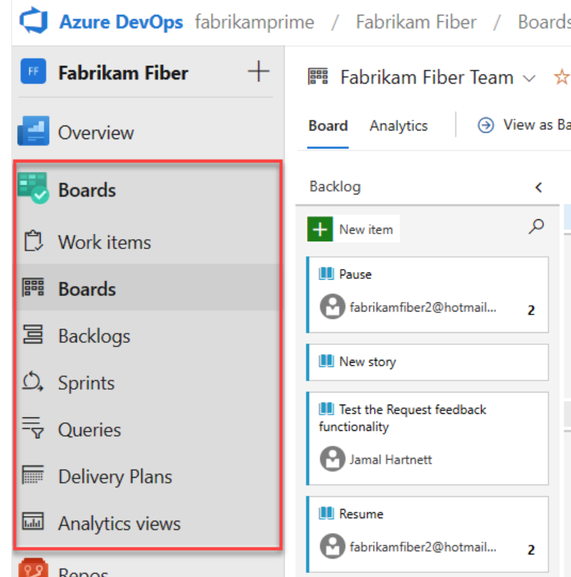

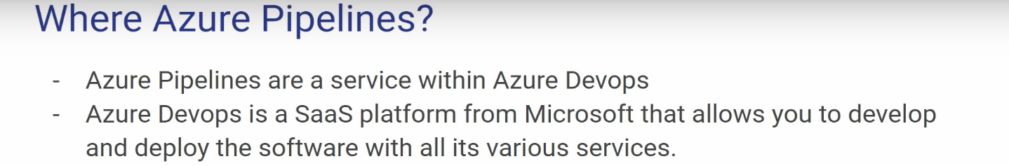

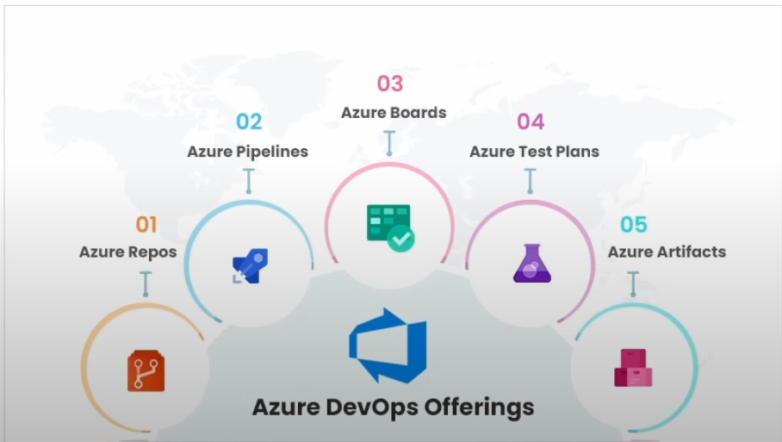

**Types of Pipelines in Azure:**

1. Azure Pipelines (CI/CD Pipelines)
2. Data Pipelines (Azure Data Factory)
3. Synapse Pipelines
4. Machine Learning Pipelines

A **YAML pipeline** in Azure refers to a pipeline defined using YAML (Yet Another Markup Language) syntax.  
  
**Structure of a YAML Pipeline**

A YAML pipeline consists of stages, jobs, steps, tasks, and triggers, arranged in a hierarchical structure.

Here’s an example of a simple YAML pipeline:  
  
trigger:

branches:

include:

- main

pool:

vmImage: 'ubuntu-latest'

stages:

- stage: Build

jobs:

- job: BuildJob

steps:

- task: UseDotNet@2

inputs:

packageType: 'sdk'

version: '6.x'

installationPath: $(Agent.ToolsDirectory)/dotnet

- script: dotnet build

displayName: 'Build Solution'

- stage: Deploy

dependsOn: Build

jobs:

- job: DeployJob

steps:

- script: echo "Deploying to Production"

displayName: 'Deploy'